**CO544: Machine Learning and Data Mining**

**Machine Learning Lab Two**

Ranage R.D.P.R. - E/19/310

**1. 2. Generate 100 samples each from two bi-variate Gaussian densities with distinct means m1 = [0,5] and m2 = [5,0], and identical covariance matrix C = [[2, 1],[ 1, 2] ]. Concatenate data from two classes into one array.**

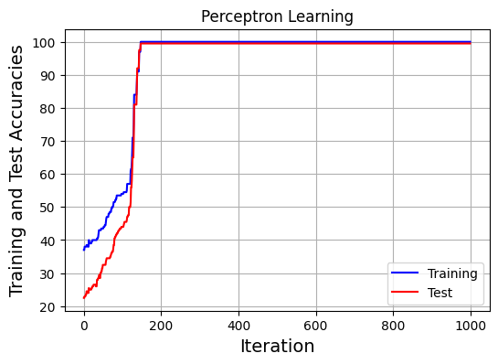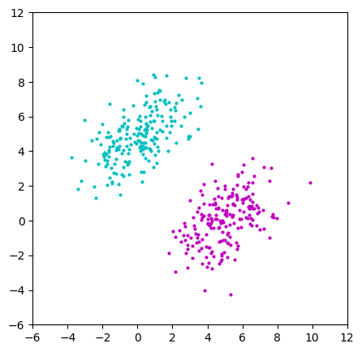

**6. 7. Iterative error correcting learning, Plot learning curves**

[0.5878141 0.04108248]

Initial Percentage Correct: 37.00

Percentage Correct After Training: 100.00 99.50

**9. Consider the problem with means at m1 = [2.5, 2.5], m2=[10, 10] with the covariance matrices equal and the same as before. Does the perceptron as implemented solve this problem?**

No.

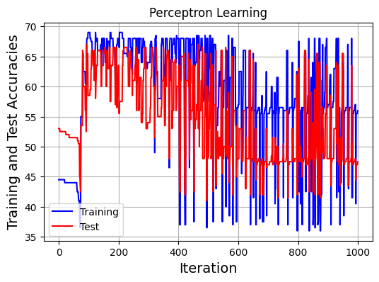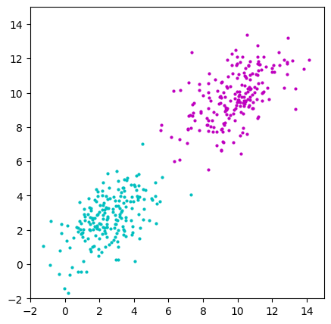(200, 2) (200,) (200, 2) (200,)

[0.63383218 1.01275821]

Initial Percentage Correct: 44.50

Percentage Correct After Training: 56.00 47.50

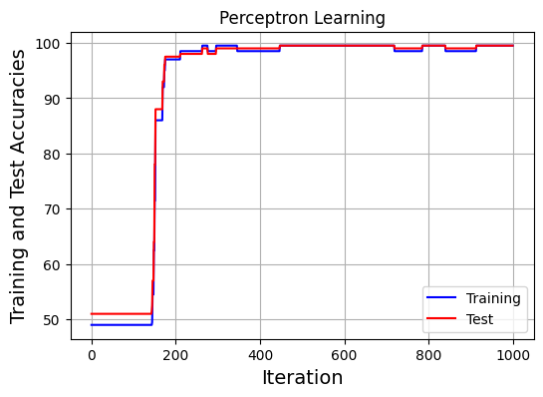**If not, what modification is needed to help solve this problem?**

By increasing the number of columns and weights and making appropriate adjustments.

Here, a new feature is added.

(200, 3) (200,) (200, 3) (200,)

[0.80443831 0.44942201 1.54508533]

Initial Percentage Correct: 49.00

Percentage Correct After Training: 99.50 99.50

**10. Download a two-class classification problem from the UCI machine Learning Repository of benchmark datasets https://archive.ics.uci.edu/ml/index.php and classify using your own perceptron algorithm.**

This dataset is randomly collected from an Iranian telecom company database over a period of 12 months. A total of 3150 rows of data, each representing a customer, bear information for 13 columns. The attributes that are in this dataset are call failures, frequency of SMS, number of complaints, number of distinct calls, subscription length, age group, the charge amount, type of service, seconds of use, status, frequency of use, and Customer Value.



[-2.03941576 -0.44279134 1.66287475 0.40565094 -0.63973118 0.76900936

1.46401175 -0.01967425 -0.13822938 0.80618588 -0.964946 0.43903994

-0.96712598]

Initial Percentage Correct: 31.86

Percentage Correct After Training: 73.75 69.76

